The Black Sea Archaeology as a Factor in Cultural Tourism
International Scientific – Practical Conference
10 – 12 October 2022
Nessebar, Bulgaria
In the frame of the project
BSB867 Black Sea Archaeology, History and Culture Portal
The project is co-financed by the EU
Joint Operational Programme Black Sea Basin 2014-2020
The Black Sea Basin Programme is funded by the European Neighbourhood Instrument (ENI), European Regional Development Fund and the Instrument for Pre-accession Assistance

CONTENTS:

- The Conference Speakers
- The Project Partners
- The Opening of the International Scientific-Practical Conference
- The Conference Sessions:

SESSION I:
Prof. Dr. Diana Gergova
The role of the women in the archaeology in the Bulgarian Euxinus Pontus

SESSION II:
Arch. Maria Karazlateva
The Black and White Sea civilization Yin-Yang

SESSION III:
Dr. Nayden Prahov
Underwater archaeological research in Nessebar

SESSION IV:
Drd. Cristian Cealera
Dr. Cristina Talmatchi
Contributions of some women from Romania to the development and promotion of archaeology in the west of the Black Sea;

SESSION V:
Dr. Ana Cristina Hamat
Dr. Aurel Mototolea
Dr. Stefan Georgescu
Cultural routes on the Black Sea shore. Case study: the archaeological sites from Nessebar to Sulina

SESSION VI:
Dr. Denis Topal
National Museum of the History of Moldova: results of digitalization program (2020-2022)
SESSION VII:
Mariana Vasilache
Soft hands for hard professions. Moldovan female archaeologists in time

- CONFERENCE SPEAKERS:

Prof. Dr. Diana Gergova
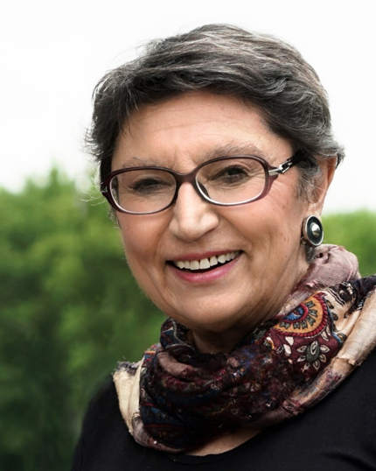
Prof. D.Sc. Ph.D. Diana Gergova is one of the most prominent specialists in Thracian archaeology in Bulgaria. She graduated with a degree in History and Archeology from the University of St. Kliment Ohridski" and currently works at the National Archaeological Institute with a museum at the Bulgarian Academy of Sciences (BAS). She is a member of national and international organizations, including the Governing Board of the National Committee of ICOMOS - UNESCO, the Scientific Committee on Funerary Archeology - Braila, the World Archaeological Congress - member and coordinator for Central and Eastern Europe and Asia.
She led the excavations of the settlement mound near the village of Dyadovo, the Geta religious and political center in the National Reserve "Sboryanovo", sites in Ahtopol, the Thracian sanctuaries of the demons at the monastery "St. Ilia", Velingrad, and the sanctuary of Dionysus on Mount Ostrets, Velingrad, on the Thracian necropolises in the Western Rhodopes near the villages of Kochan, Satovcha and Lyubcha. In 2001, the American Biographical Institute honored her with the Woman of the Year Award in Archeology and Business.
She is the author of books and 200 scientific articles. In 2019, the Government of Japan honored her services for promoting academic exchange and mutual understanding between Japan and Bulgaria in the field of archeology with the State Order of the Rising Sun - Golden Rays with Rosette.

Arch. Maria Karazlateva
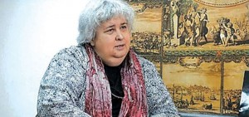
Arch. Maria Karazlateva completed her higher education at the Higher Civil Engineering Institute, currently the University of Architecture, Construction and Geodesy in Bulgaria. She is a leading expert on the preservation of cultural heritage and a member of the Union of Architects in Bulgaria (SAB).
She was awarded the scientific title "senior research associate" of the Public Academy of Science, Education, Culture (OANOK).
There are a number of territorial and development plans developed in the country, including a concept plan for the preservation of the medieval structural heritage of the "Great Lavra" monastery complex, the historical nature-urban complexes of Tsarevets, Trapezitsa, Momina Fortress and Arbanasi, a planning assignment for the development of POU for Old Nessebar.
She has developed a concept, building plan and architectural projects for the renovation of the National History Museum "Birth House of Vasil Levski" in Karlovo. She is the author of a number of conceptual projects, including "Marine Strategy of the Republic of Bulgaria, Ecological Assessment by component "CIN-underwater archeology" in the scope of the Black Sea shelf.

Dr. Nayden Prahov
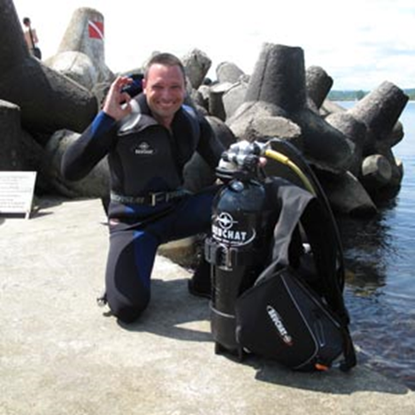
Dr. Nayden Lyubomirov Prahov is a Bulgarian scientist, archaeologist. Since 2015, he has been working as an archaeologist at the National Archaeological Institute with a museum at the Bulagrian Academy of Sciences (BAS), and since 2020 he has been the director. He completed his education at the Department of Archeology at Sofia University "St. Kliment Ohridski". He successfully defended his PhD thesis on: "Interdisciplinary Paleoenvironmental Reconstruction Methods and Predictive Modeling for the Identification of Underwater Archaeological Sites", part of which he developed in collaboration with the Center for Advanced Spatial Technologies at the Institute for Digital Archeology at the University of Arkansas.
His research interests are focused on methods and practices in archaeological excavation and documentation of archaeological sites; remote sensing models in marine surveys; predictive models for underwater and coastal archaeological sites; GIS and spatial analyses; sunken prehistoric settlements; landscape changes and palaeoenvironmental reconstruction.
He has been involved in numerous archaeological projects over the years. After 2010, the studies in which he participated and led were mainly on sites in the Black Sea area.
He is the author of books, has numerous publications related to the conducted studies.
Dr. Nayden Prahov is co-founder and co-director of the NGO "Balkan Heritage Foundation and Field Archeology School".

Drd. Cristian Cealera
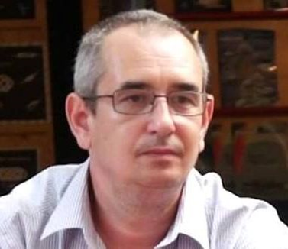
Cristian Cealera attended the master's courses of the "Ovidius" University of Constanța, Faculty of History and Political Sciences, Section of Anthropology and European History. He completed his studies at the "A.I Cuza" University in Iași, where this year he presented his PhD thesis with the title "Cult of the goddess Cybele in the Roman province of Moesia Inferior - The interaction of the Great Mother of Gods with the native divinities". He is an employee of the Constanța Museum of National History and Archeology as a museum educator and he participates annually in the archaeological research at the Tropaeum Traiani. He is also a writer, publicist and producer of TV shows and documentary films, all of which have as their main theme the promotion of the cultural-historical heritage of the former Roman province of Scythia Minor.

Dr. Ana Cristina Hamat
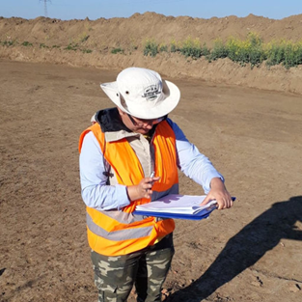
A.C. Hamat has studied Archaeology at the West University from Timișoara, where she did also here Ph.D. thesis with the titles: Women's jewelry and clothing accessories from Romanian Dacia: with a special focus on Dacia Superior. She has worked as an archaeologist in the museum from Caransebes and Resita, and currently is working at the Museum of National History andArchaeology from Constanta as an archeologist specialized in classical archaeology. She conducts archaeological investigation at Tibiscum, Berzovia, Constanta and Danube's Gorge area at Coronini and Gornea and she is an expert in small finds and in limes archaeology, within terestsin metalworking, gems and cameos and ancient technology for both Roman and Late Roman periods.

Dr. Denis Topal
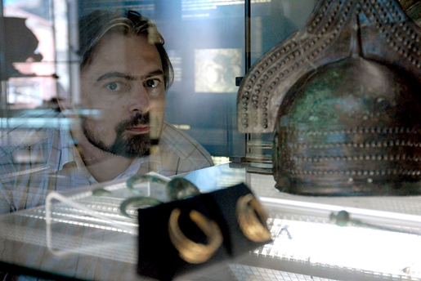
Dr. Denis Topal, Archaeology Department, National Museum of History of Moldova
is an archaeologist specializing in the archaeology of the early nomads of Eurasia. His research background is in the analysis of trends in the development of warfare in European cultures in the Iron Age. His expertise also includes Late Bronze Age and Early Iron Age deposits and the archaeology of burial mounds in the Pontic steppe in prehistory. D. Topal received his PhD from the Academy of Sciences of the Republic of Moldova in 2018 with the thesis "Scythian blade weaponry of 7th-4th centuries BC (South-western part of Eastern Europe)". Since 2017, D. Topal has been working as the Head of the Documentation Department of the National Agency of Archaeology of the Republic of Moldova, since 2020 he is working as a research fellow at the National Museum of History of the Republic of Moldova in Chișinău, and since 2022 he has been a corresponding member of the German Archaeological Institute. He has published more than 80 articles and presented papers at more than 30 international conferences. In addition, since 2010 he is associate editor of Stratum plus journal (volume dedicated to the Iron Age).
Mariana Vasilache
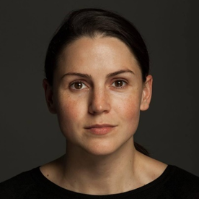
For the last 15 years Mariana Vasilache gathered an experience working in the cultural sector. Currently activating as archaeologist at the National Museum of History of Moldova.
As part of my duties, I am contributing to the collection, examination, analysis and generalization of scientific museology information and the digitization of archaeological heritage from museum collections. The interest area in archaeology is the Copper Age of the South-Eastern Europe, with a focus on the Cucuteni-Trypillya culture. As well, in order to share the cultural heritage, she is part of a team who organize and update permanent and temporary exhibitions, both local, for the National Museum of History of Moldova and international, organising scientific conferences, public lectures and educational activities.

II. THE PROJECT PARTNERS:

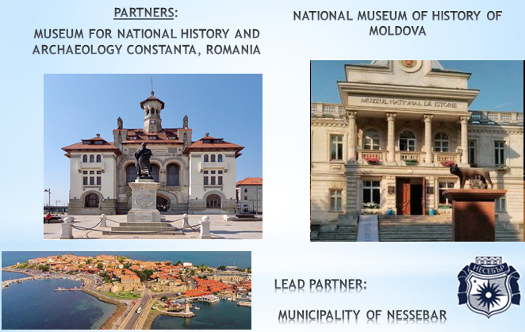

III. Opening of the International Scientific-Practical Conference

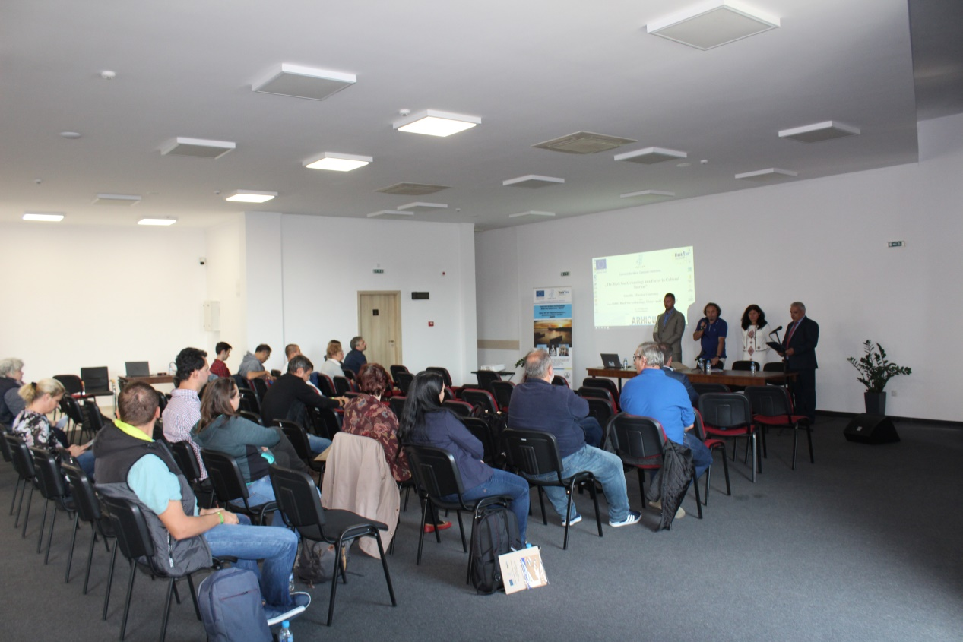
Opening of the conference and welcome address by Mr. Ivan Gurgov,
Deputy Mayor of Nessebar Municipality

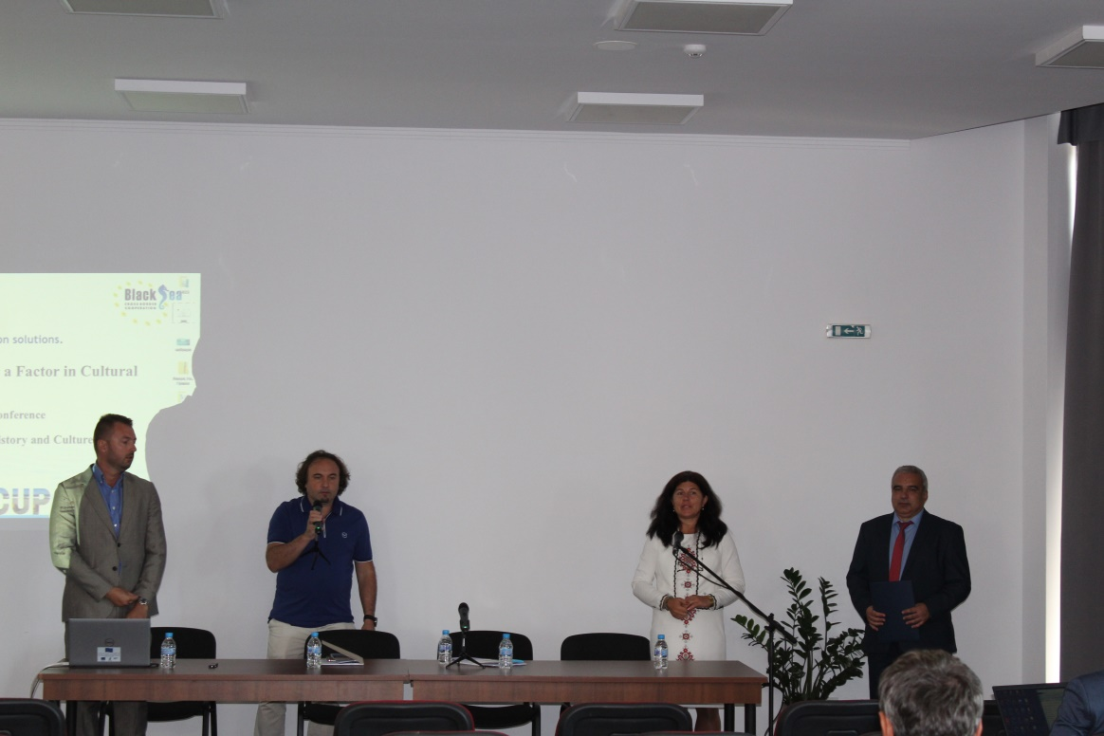

- Conference Sessions

All conference presentations are uploaded under section Scientific-Practical Conference:
In English:
SESSION I:
Prof. Dr. Diana Gergova
National Academy of Art, Sofia;
Member of the Bulgarian National Committee (BNC) of ICOMOS;
The role of the women in the archaeology in the Bulgarian Euxinus Pontus

SESSION II:
Arch. Maria Karazlateva
Senior research associate of Public Academy of Science, Education and Culture
The Black and White Sea civilization Yin-Yang

SESSION III:
Dr. Nayden Prahov
Center for Underwater Archaeology – Ministry of Culture of the Republic of Bulgaria
Underwater archaeological research in Nessebar

SESSION IV:
Drd. Cristian Cealera
Dr. Cristina Talmatchi
Museum of National History and Archaeology Constanţa
Contributions of some women from Romania to the development and promotion of archaeology in the west of the Black Sea;

SESSION V:
Dr. Ana Cristina Hamat
Dr. Aurel Mototolea
Dr. Stefan Georgescu
Museum of National History and Archaeology Constanţa
Cultural routes on the Black Sea shore. Case study: the archaeological sites from Nessebar to Sulina

SESSION VI:
Dr. Denis Topal
National Museum of History of Moldova
National Museum of the History of Moldova: results of digitalization program (2020-2022)
SESSION VII:
Mariana Vasilache
National Museum of History of Moldova
Soft hands for hard professions. Moldovan female archaeologists in time

In Bulgarian:
Сесия 1:
Проф. д-р Диана Герговa
Национална Художествена Академия, гр. София;
Член на Български Национален Комитет (БНК) на ИКОМОС;
Ролята на жените в археологията на българския Евксинос Понтос

Сесия 2:
Арх. Мария Каразлатева
Старши научен сътрудник на Обществена академия за наука, образование и култура (ОАНОК)
Черно-беломорският цивилизационен Ин-ян

Сесия 3:
Д-р Найден Прахов
Център за подводна археология – Министерство на културата на РБ
„Подводни археологически проучвания в Несебър“

Сесия 4:
Д-р-д Кристиан Чеaлера
Д-р Кристина Талмачи
Музей за национална история и археология Константа
Жените от Румъния и техния принос за развитието и популяризирането на археологията на запад от Черно море

Сесия 5:
Д-р Ана Кристина Хамат
Д-р Аурел Мототолеа
Д-р Стефан Георгеску
Музей за национална история и археология Константа
Културните маршрути по брега на Черно море. Конкретно проучване: археологическите обекти от Несебър до Сулина

Сесия 6:
Д-р Денис Топал
Национален исторически музей на Молдова
Националният исторически музей на Молдова: резултати от програмата за дигитализация (2020-2022 г.)

Сесия 7:
Г-жа Мариана Василаке
Национален исторически музей на Молдова
Нежни ръце за сурови професии. Молдовски дами-археолози през вековете

